**SOFTWARE ENGINEERING**

**LECTURE 5**

***The software processes***

A structured set of activities required to develop a software system.

* Many different software processes but all involve:
* Specification – defining what the system should do;
* Design and implementation – defining the organization of the system and implementing the system;
* Validation – checking that it does what the customer wants;

Evolution – changing the system in response to changing customer needs.

* A software process model is an abstract representation of a process. It presents a description of a process from some particular perspective.

***Software process descriptions***

* When we describe and discuss processes, we usually talk about the activities in these processes such as specifying a data model, designing a user interface, etc. and the ordering of these activities.
* Process descriptions may also include:
  + Products, which are the outcomes of a process activity;
  + Roles, which reflect the responsibilities of the people involved in the process;

Pre- and post-conditions, which are statements that are true before and after a process activity has been enacted or a product produced.

***Plan-driven and agile processes***

* Plan-driven processes are processes where all of the process activities are planned in advance and progress is measured against this plan.
* In agile processes, planning is incremental and it is easier to change the process to reflect changing customer requirements.
* In practice, most practical processes include elements of both plan-driven and agile approaches.
* There are no right or wrong software processes.

***Software process models***

* ***The waterfall models***
  + Plan-driven model. Separate and distinct phases of specification and development.
* ***Incremental development***
  + Specification, development and validation are interleaved. May be plan-driven or agile.
* ***Integration and configuration***
  + The system is assembled from existing configurable components. May be plan-driven or agile.
* In practice, most large systems are developed using a process that incorporates elements from all of these models.

***The waterfall models***

**2.1.Waterfall-model.eps**

***Waterfall model phases***

* There are separate identified phases in the waterfall model:
  + Requirements analysis and definition
  + System and software design
  + Implementation and unit testing
  + Integration and system testing
  + Operation and maintenance
* The main drawback of the waterfall model is the difficulty of accommodating change after the process is underway. In principle, a phase has to be complete before moving onto the next phase.

***Waterfall model problems***

* Inflexible partitioning of the project into distinct stages makes it difficult to respond to changing customer requirements.
  + Therefore, this model is only appropriate when the requirements are well-understood and changes will be fairly limited during the design process.
  + Few business systems have stable requirements.
* The waterfall model is mostly used for large systems engineering projects where a system is developed at several sites.
  + In those circumstances plan-driven nature of waterfall model helps coordinate the work.

***Incremental development***

**2.2 Incremental-dev.eps**

***Incremental development benefits***

* The cost of accommodating changing customer requirements is reduced.
  + The amount of analysis and documentation that has to be redone is much less than is required with the waterfall model.
* It is easier to get customer feedback on the development work that has been done.
  + Customers can comment on demonstrations of the software and see how much has been implemented.
* More rapid delivery and deployment of useful software to the customer is possible.

Customers are able to use and gain value from the software earlier than is possible with a waterfall process

***Incremental development problems***

* ***The process is not visible.***

Managers need regular deliverables to measure progress. If systems are developed quickly, it is not cost-effective to produce documents that reflect every version of the system.

* ***System structure tends to degrade as new increments are added.***

Unless time and money spent on refactoring, to improve software regular change tends to corrupt its structure. Incorporating further software changes becomes increasingly difficult and costly.

***Integration and configuration***

* Based on software reuse where systems are integrated from existing components or application systems (**sometimes called COTS -Commercial-off-the-shelf) systems**).
* Reused elements may be configured to adapt their behaviour and functionality to a user’s requirements
* Reuse is now the standard approach for building many types of business system
  + Reuse covered in more depth in Chapter 15.

***Types of reusable software***

* Stand-alone application systems (sometimes called COTS) that are configured for use in a particular environment.
* Collections of objects that are developed as a package to be integrated with a component framework such as .NET or J2EE.

Web services that are developed according to service standards and which are available for remote invocation

***Reuse-oriented software engineering***

**2.3 Reuse oriented SE.eps**

***Key process stages***

* Requirements specification
* Software discovery and evaluation
* Requirements refinement
* Application system configuration
* Component adaptation and integration

***Advantages and disadvantages***

* Reduced costs and risks as less software is developed from scratch
* Faster delivery and deployment of system
* But requirements compromises are inevitable so system may not meet real needs of users
* Loss of control over evolution of reused system elements

***Process activities***

* Real software processes are inter-leaved sequences of technical, collaborative and managerial activities with the overall goal of specifying, designing, implementing and testing a software system.
* The four basic process activities of specification, development, validation and evolution are organized differently in different development processes.
* For example, in the waterfall model, they are organized in sequence, whereas in incremental development they are interleaved.

***The requirements engineering process***

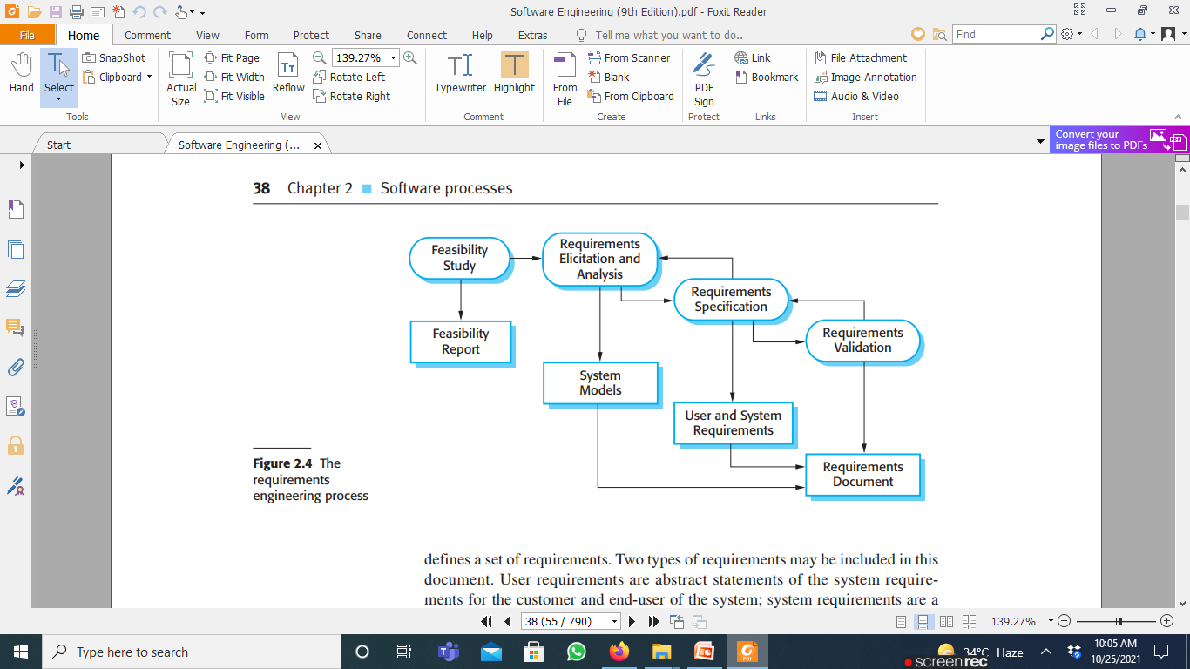

**Software specification**

* The process of establishing what services are required and the constraints on the system’s operation and development.

***Requirements engineering process***

***Requirements elicitation and analysis***

* + - What do the system stakeholders require or expect from the system?

***Requirements specification***

* + - Defining the requirements in detail

***Requirements validation***

* + - Checking the validity of the requirements

***Software design and implementation***

The process of converting the system specification into an executable system.

***Software design***

* + Design a software structure that realises the specification;

***Implementation***

* + Translate this structure into an executable program;

The activities of design and implementation are closely related and may be inter-leaved.

***A general model of the design process***

**2.5 Design-process.eps**

***Design activities***

* ***Architectural design****,* where you identify the overall structure of the system, the principal components (subsystems or modules), their relationships and how they are distributed.
* ***Database design,***where you design the system data structures and how these are to be represented in a database.
* ***Interface design****,* where you define the interfaces between system components.
* ***Component selection and design,***where you search for reusable components. If unavailable, you design how it will operate.

***System implementation***

* The software is implemented either by developing a program or programs or by configuring an application system.
* Design and implementation are interleaved activities for most types of software system.
* Programming is an individual activity with no standard process.
* Debugging is the activity of finding program faults and correcting these faults.

***Software validation***

* Verification and validation (V & V) are intended to show that a system conforms to its specification and meets the requirements of the system customer.
* Involves checking and review processes and system testing.
* System testing involves executing the system with test cases that are derived from the specification of the real data to be processed by the system.

Testing is the most commonly used V & V activity.

***Stages of testing***

**2.6 Testing-process.eps**

***Testing stages***

* ***Component testing***
  + Individual components are tested independently;
  + Components may be functions or objects or coherent groupings of these entities.
* ***System testing***
  + Testing of the system as a whole. Testing of emergent properties is particularly important.
* ***Customer testing***
  + Testing with customer data to check that the system meets the customer’s needs.

***Testing phases in a plan-driven software process (V-model)***

**2.7 Testing-phases.eps**

***Software evolution***

* Software is inherently flexible and can change.
* As requirements change through changing business circumstances, the software that supports the business must also evolve and change.

Although there has been a demarcation between development and evolution (maintenance) this is increasingly irrelevant as fewer and fewer systems are completely new

***System evolution***

**2.8 System evolution.eps**